Nexatech School Pilot Proposal and Budget
A 30-day evaluation of student records, marks, results, and attendance
Nexatech is a school operations platform that brings routine administrative and academic work into one controlled system. Staff capture information once, authorized users retrieve it when needed, and the school keeps a clearer operational record.
This proposal recommends a focused 30-day pilot. The school can test the system using an agreed data set, named staff, measurable workflows, and a defined budget before deciding on a wider rollout.

Recommended Offer
Item | Scope | Recommended price
30-day pilot | Configuration, one clean import, one administrator, up to 10 teachers, training, 30-day pilot hosting, database, backups, and support | US$299 once
Academic plan | Up to 500 active learners, records, Fast Marks, assessments, results, report cards, attendance, and exports | US$179 per month
Operations plan | Academic plan plus finance, timetable, communications, behaviour, parent portal, and priority support | US$299 per month
Public API access | One documented integration, scoped credentials, logs, standard rate limit, and key rotation support | US$49 per month
Managed domain and hosting | Railway deployment, custom domain, HTTPS, standard service monitoring, and routine platform maintenance | US$50 per month

Pilot fee credit: if the school signs the Academic or Operations plan within 14 days of the pilot review, apply the US$299 pilot fee toward the standard US$350 onboarding charge.
Separate charges: SMS, email, payment-provider charges, taxes, complex historical data cleaning, custom integrations, and dedicated database resources are quoted separately.

What the School Will See
- An operational dashboard showing student and billing information.
- A searchable student register with role-controlled actions.
- Fast Marks for class, subject, term, assessment, and roster-based entry.
- Class results and rankings that staff can retrieve by term and year.
- Attendance registers with status and remarks.
- A route into finance, timetables, communications, behaviour, examinations, report cards, and parent access.
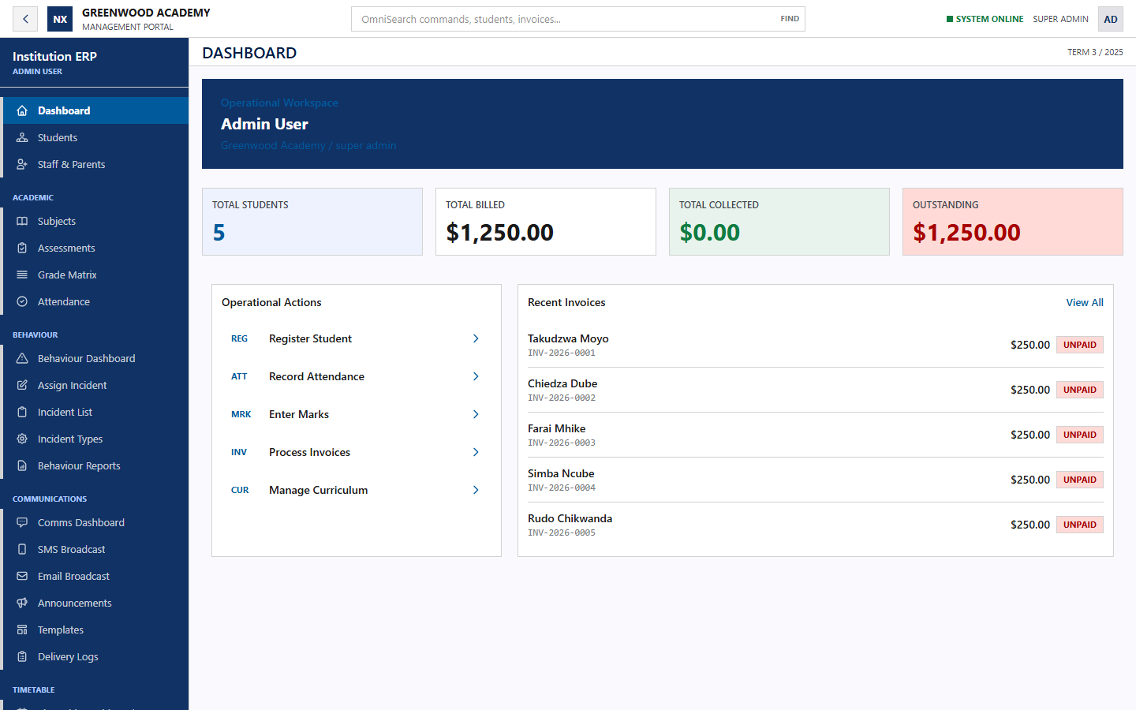
Operational dashboard using synthetic Greenwood Academy demonstration data

Pilot Demonstration Agenda
Time | Demonstration | Decision point
5 minutes | Current school process and agreed pilot problem | Confirm the workflow that matters most
5 minutes | Role-based login, navigation, and student register | Confirm users and access boundaries
10 minutes | Fast Marks entry and safe retrieval | Confirm required assessment process
5 minutes | Class results and attendance | Confirm reporting and register expectations
5 minutes | Pilot scope, budget, data preparation, and next steps | Nominate school lead and pilot dates

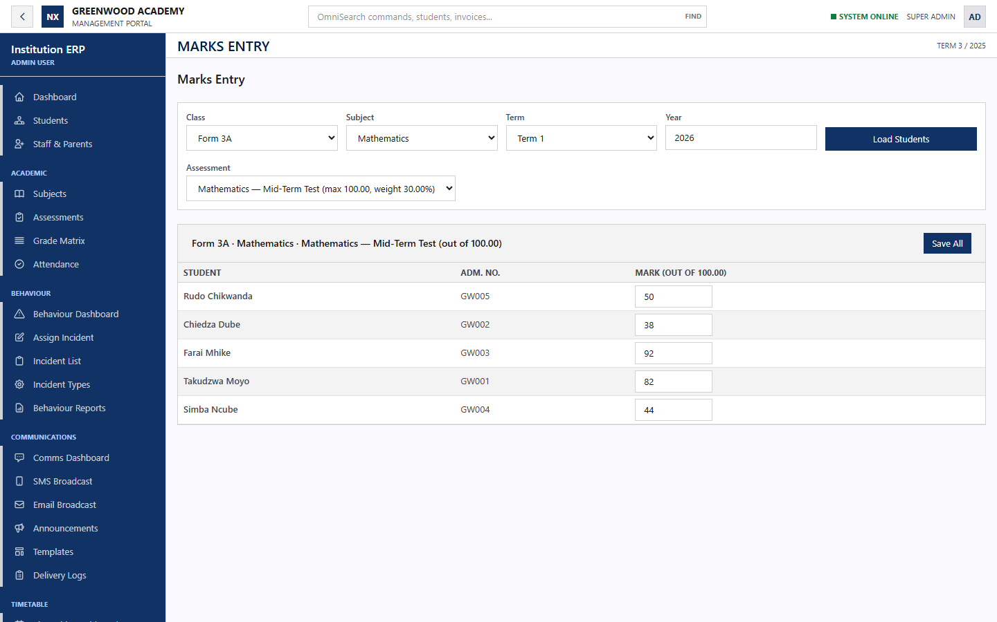
Fast Marks demonstration with synthetic class and assessment records

Pilot Plan
Period | Nexatech work | School participation
Week 1 | Configure the workspace and import one clean data file | Approve scope, data fields, named users, and school lead
Week 2 | Train the administrator and teachers | Attend training and confirm the operating process
Week 3 | Support student records, marks, results, and attendance | Use the agreed workflows and report issues
Week 4 | Review outcomes and recommend the next rollout | Assess value, risks, and the continuation decision

Pilot Success Measures
- A teacher can complete a 40-learner assessment in under five minutes.
- Common student and results views respond in under two seconds under normal pilot load.
- Retries do not create duplicate marks or student records.
- Every rejected import row shows an actionable reason.
- The school can export its records and Nexatech can demonstrate a successful backup restore.

System Dependencies and Libraries
The list below covers direct project dependencies and the main production runtime components. Package managers also install transitive dependencies required by these libraries.

Frontend Application
Component | Version | Purpose
React | 19.2.6 | User interface and role-specific application screens
React DOM | 19.2.6 | Browser rendering for React
Vite | 8.0.14 | Development server and production frontend build
Tailwind CSS | 4.3.0 | Layout and visual styling
Tailwind Vite plugin | 4.3.0 | Tailwind integration with the build
Axios | 1.16.1 | Authenticated browser requests to the Laravel API
Playwright | 1.60.0 | Browser testing and repeatable demonstrations
ESLint toolchain | 10.x | JavaScript quality checks, React hooks rules, and development globals
React type packages | 19.2.x | Development type information

Backend Application
Component | Version | Purpose
PHP | 8.3 minimum; 8.4 production image | Server runtime
Laravel Framework | 13.8 | API, authentication, validation, queues, scheduling, and business logic
Laravel Sanctum | 4.0 | Authenticated sessions and access tokens
Laravel Tinker | 3.0 | Controlled administrative troubleshooting
Laravel DOMPDF | 3.1 | PDF report-card generation
Paynow PHP SDK | 1.0 | Paynow payment integration
PHP extensions | bcmath, gd, intl, pdo_mysql, zip, redis | Calculations, images, localization, database, archives, queues, and cache
Test and development libraries | Faker, Pail, Pao, Pint, Mockery, Collision, PHPUnit | Fixtures, logs, quality checks, mocks, diagnostics, and automated tests

System and Service Dependencies
Dependency | Use
Docker | Builds one repeatable production image
Node.js 22 and npm | Build the React frontend
Composer 2 | Installs and optimizes PHP packages
Apache | Serves the built frontend and Laravel application
Managed MySQL | Production source of truth for school records
Redis | Queues, cache, and session support
SMTP service | Password recovery and transactional email
Africa's Talking | Optional SMS delivery
Paynow, Payfast, or Stitch | Optional payment processing through configured gateways

Hosting and Production Architecture
The current deployment design uses Railway and Docker. The React application and Laravel API share one HTTPS origin because the secure authentication design uses HTTP-only cookies.
Service | Responsibility
Web service | Serves the React frontend and Laravel API, runs migrations, and exposes the health check
Worker service | Processes queued email, SMS, payment confirmation, and other background jobs
Scheduler service | Runs scheduled work such as retention pruning
Managed MySQL | Stores tenant-scoped operational data
Managed Redis | Supports queues, cache, and production sessions
Custom domain and HTTPS | Provides the school-facing address and encrypted transport
Monitoring and backups | Tracks health, failures, database pressure, and recovery readiness

Domain API and Secret Management
- Use one final product domain with HTTPS and domain-based sender addresses.
- Store application, database, email, SMS, payment, and partner credentials in the hosting secret manager.
- Never place API keys in the React frontend, screenshots, source control, proposals, or training material.
- Issue a unique key for each customer integration with narrow permissions, rate limits, rotation, logs, and revocation.
- Charge for managed API access and usage, not for revealing a provider secret.

Readiness Conditions Before Real School Data
- Complete tenant-isolation and role-permission checks for the exact pilot roles.
- Confirm automated encrypted backups and complete a documented restore test.
- Activate uptime, application-error, queue-failure, and database alerts.
- Configure and test SMTP before relying on password recovery or demo access email.
- Configure SMS and payment credentials only for services included in the pilot.
- Approve the privacy notice, terms, retention policy, data-processing responsibilities, and incident contact process.
- Use synthetic data for sales demonstrations. Import real school data only after written approval and secure transfer arrangements.

Next Decision
The school and Nexatech should agree the pilot workflow, nominate one school lead, approve the data set, confirm the price, and schedule a 30-minute demonstration. The pilot should begin only after both sides sign the scope and data-handling responsibilities.

